Risk Prioritization and Risk Scoring

1-Risk Prioritization

🔹 Definition
# Source: AI Source: Provided by: [Data Path: Persons Table -> ID Column: 1, Name_En Column: Motasem Essam] -> From: [Chatgpt (GPT‑5 Mini)] on [8/24/2025]
Risk Prioritization is the process of ranking identified risks based on their potential impact and probability in order to focus on the most critical risks first.
It helps the project team decide which risks need immediate attention and resources.

🛠️ Objectives of Risk Prioritization
# Source: AI Source: Provided by: [Data Path: Persons Table -> ID Column: 1, Name_En Column: Motasem Essam] -> From: [Chatgpt (GPT‑5 Mini)] on [8/24/2025]
- Identify high-priority risks that could severely affect the project.
- Allocate resources efficiently to mitigate the most critical risks.
- Support risk response planning and decision-making.
- Ensure proactive management of risks rather than reactive handling.

🔹 Factors Considered in Risk Prioritization
# Source: AI Source: Provided by: [Data Path: Persons Table -> ID Column: 1, Name_En Column: Motasem Essam] -> From: [Chatgpt (GPT‑5 Mini)] on [8/24/2025]
- Probability / Likelihood
  - How likely the risk is to occur.
  - Scale: Low, Medium, High or 0–100%.
- Impact / Severity
  - The effect on the project if the risk occurs.
  - Scale: Low, Medium, High or numeric values.
- Risk Score / Risk Index
  - Combines probability and impact to quantify risk priority.
  - Formula (common method):
Risk Score=Probability×Impact\text{Risk Score} = \text{Probability} \times \text{Impact}
- Urgency / Time Sensitivity
  - How soon the risk may occur.
- Detectability / Early Warning
  - How easily the risk can be detected before it causes problems.

🔹 Techniques for Risk Prioritization
# Source: AI Source: Provided by: [Data Path: Persons Table -> ID Column: 1, Name_En Column: Motasem Essam] -> From: [Chatgpt (GPT‑5 Mini)] on [8/24/2025]
- Risk Matrix / Probability-Impact Matrix
  - Plot risks on a grid of probability vs impact to visualize priority.
- Scoring or Rating Method
  - Assign numerical values for probability and impact, then calculate risk score.
- Expert Judgment
  - Use insights from experienced team members to rank risks.
- Pareto Analysis (80/20 Rule)
  - Focus on the 20% of risks that may cause 80% of potential problems.

📊 Example Scenario
# Source: AI Source: Provided by: [Data Path: Persons Table -> ID Column: 1, Name_En Column: Motasem Essam] -> From: [Chatgpt (GPT‑5 Mini)] on [8/24/2025]
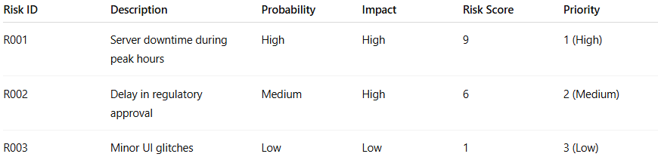
Risk ID | Description | Probability | Impact | Risk Score | Priority
R001 | Server downtime during peak hours | High | High | 9 | 1 (High)
R002 | Delay in regulatory approval | Medium | High | 6 | 2 (Medium)
R003 | Minor UI glitches | Low | Low | 1 | 3 (Low)
Interpretation:
- R001 → highest priority, needs immediate mitigation.
- R002 → medium priority, monitor and plan.
- R003 → low priority, can be addressed later.

🔑 Importance of Risk Prioritization
# Source: AI Source: Provided by: [Data Path: Persons Table -> ID Column: 1, Name_En Column: Motasem Essam] -> From: [Chatgpt (GPT‑5 Mini)] on [8/24/2025]
- Focuses time, effort, and resources on critical risks.
- Ensures effective mitigation for high-impact risks.
- Helps in decision-making and proactive project management.
- Reduces the likelihood of project failure or severe disruptions.

✅ In short:
Risk Prioritization = The process of ranking identified risks based on their probability, impact, and urgency so that the most critical risks are addressed first.

2-Risk Scoring

🔹 Definition
# Source: AI Source: Provided by: [Data Path: Persons Table -> ID Column: 1, Name_En Column: Motasem Essam] -> From: [Chatgpt (GPT‑5 Mini)] on [8/24/2025]
Risk Scoring is the process of quantifying the severity of a risk by assigning numerical values to its probability (likelihood) and impact (severity).
It helps in prioritizing risks objectively so that the most critical risks can be addressed first.

🛠️ Key Components of Risk Scoring
# Source: AI Source: Provided by: [Data Path: Persons Table -> ID Column: 1, Name_En Column: Motasem Essam] -> From: [Chatgpt (GPT‑5 Mini)] on [8/24/2025]
- Probability / Likelihood
  - Measures how likely the risk is to occur.
  - Scale examples:
    - Low = 1
    - Medium = 2
    - High = 3
  - Or as a percentage (0–100%).
- Impact / Severity
  - Measures the effect of the risk on project objectives if it occurs.
  - Scale examples:
    - Low = 1
    - Medium = 2
    - High = 3
- Risk Score / Risk Index
  - Combines probability and impact into a single value:
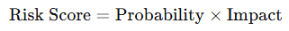
Risk Score=Probability×Impact\text{Risk Score} = \text{Probability} \times \text{Impact}
  - Higher score → higher priority.

🔹 Example of Risk Scoring
# Source: AI Source: Provided by: [Data Path: Persons Table -> ID Column: 1, Name_En Column: Motasem Essam] -> From: [Chatgpt (GPT‑5 Mini)] on [8/24/2025]
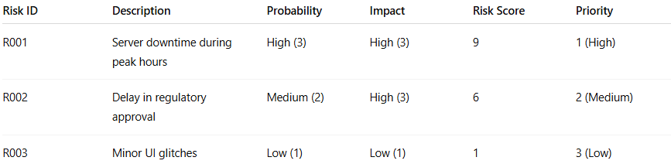
Risk ID | Description | Probability | Impact | Risk Score | Priority
R001 | Server downtime during peak hours | High (3) | High (3) | 9 | 1 (High)
R002 | Delay in regulatory approval | Medium (2) | High (3) | 6 | 2 (Medium)
R003 | Minor UI glitches | Low (1) | Low (1) | 1 | 3 (Low)
Interpretation:
- R001 → highest risk, needs immediate mitigation.
- R002 → moderate risk, plan mitigation.
- R003 → low risk, monitor or address later.

🔹 Benefits of Risk Scoring
# Source: AI Source: Provided by: [Data Path: Persons Table -> ID Column: 1, Name_En Column: Motasem Essam] -> From: [Chatgpt (GPT‑5 Mini)] on [8/24/2025]
- Provides objective prioritization of risks.
- Helps in decision-making and resource allocation.
- Supports risk mitigation planning based on severity.
- Simplifies communication of risk severity to stakeholders.

✅ In short:
Risk Scoring = Assigning numerical values to the probability and impact of a risk to calculate its severity and prioritize actions accordingly.

